Lecture-01, Integral Calculus & DEs, Monday, January 24, 2022

Course Name: Integral Calculus and Differential Equations

Text/Reference Books

1. Calculus– J. Stewart, - 8th edition, Cengage Learning, Inc.

2. Differential Equations – P. Blanchard, R. L. Devaney, G. R. Hall.

3. Calculus–H. Anton, I.C. Bivens and S. Davis.-10th edition, John Wiley & Sons Inc.

4. Differential Equations – S.L. Ross.- 3rd edition, John Wiley & Sons Inc.

5. Calculus with Analytical Geometry –G.B. Thomas and R.L. Finny.- 9th edition, Addison-Wesley Publishing Company

Marks distribution

Quizzes- 40%,

MCQ(Term final)-20%

Viva 20%

Attendance and performance 10%

Assignment 10%

Grand: 40% of midterm +60% of final term

Integration sign: Sum,

Ex. Integrate

Lecture-02, Integral Calculus & DEs, Wednesday, January 26, 2022

Ex.

Integrate the following functions

Lecture-03, Integral Calculus & DEs, Monday, January 31, 2022

(ii)

+C

Integration by Trigonometric Substitution

(ii)

(i)

Integration becomes

(i) Putting



=

Alternative:

,

Putting

;

;

;

;

Evaluate

Putting



Lecture-04, Integral Calculus & DEs, Wednesday, February 02, 2022



= +c

Integration by Substitution

Putting

Putting

3.

4. , putting

5.

6.

Evaluate the following integral

,

Lecture-05, Integral Calculus & DEs, Monday, February 07, 2022

(f) , Putting

(g) ,Putting

(h) , Putting

(i) , Putting

(j), Putting

(k), Putting

(l) , Putting

(m) , Putting

(n) , Putting

Quiz-01 will be held on Monday 14/02/2021

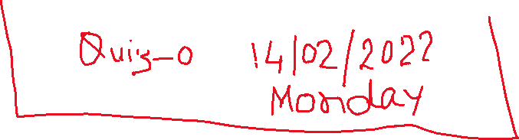

Definite Integral

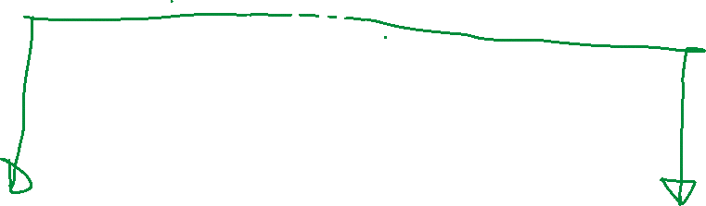

of the region bounded by the lines



Riemann Sum:

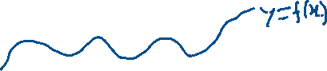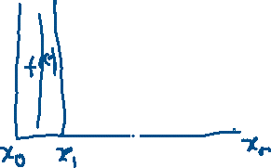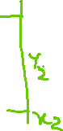

is called Riemann sum for left end point



If

Riemann sum for left end points

Riemann sum for Right end points

Riemann sum for Mid-points

Trapezoidal rule

Example1: Given length and wide in feet. Measure the following land for in both katha and decimal by Trapezoidal rule and Riemann sum for left , right, and mid points

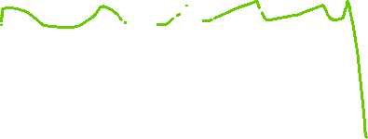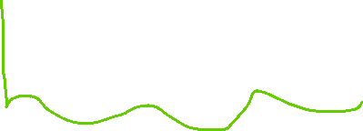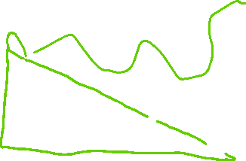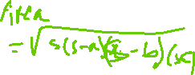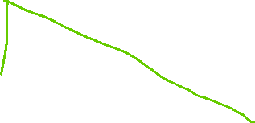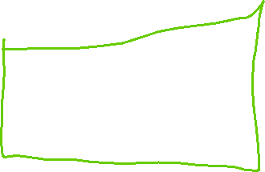

Lecture-06, Integral Calculus & DEs, Monday, February 07, 2022

Trapezoidal Rule

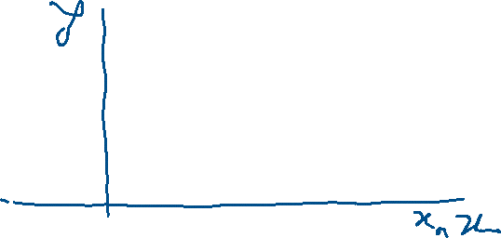

Numerical Integration: Trapezoidal rule, Riemann sum

Evaluate the following integral by

(i) Left end point Riemann sum

(ii) Right end point Riemann sum

(iii) Mid point Riemann sum

(iv) Trapezoidal rule

For

Given ,



Riemann sum for left end point



For Exact Value:

Exact

Error calculation

Percentage of error

Percentage of Error for trapezoidal rule

Percentage of error is

Percentage of error for left point Riemann sum

Percentage of error is

Percentage of error for right point Riemann sum

Percentage of error is

Percentage of error for Mid point Riemann sum

Percentage of error is

It has been observe that Trapezoidal rule and Mid-point Riemann sum give us the result near to exact result.

By Excel

X f(x) Mid f(mid)

|  |  |  |  |  |
| --- | --- | --- | --- | --- |
|  | 1 | 0.368 | 1.1 | 0.32 |
|  | 1.2 | 0.256 | 1.3 | 0.188 |
|  | 1.4 | 0.126 | 1.5 | 0.077 |
|  | 1.6 | 0.043 | 1.7 | 0.021 |
|  | 1.8 | 0.01 |  | 0.606 |
|  |  |  |  |  |
| I(T) | 0.1228 |  | R(M) | 0.1212 |
| R(L) | 0.1586 |  |  |  |
| R® | 0.087 |  |  |  |

Lecture-07, Integral Calculus & DEs, Monday, February 14, 2022

Q1. Evaluate . to three decimal places using Trapezoidal rule with four subintervals.[Note that to find the value of cos *x* or sinx you must take your calculator in radian mode]



Definite integral:



Another method: , putting

When

Lecture-08, Integral Calculus & DEs, Wednesday, February 16, 2022

Set:1.2.2

When

Ans

Integration of Odd function and even function

Odd function: If , then is called odd function

; =, is an odd function,

Even function: If , then is called even function

Integrate the following functions

(a) ,

(b)

(c) ,

(d), (e), (f) ,

(g), (h), (i) ,

Chapter2.

of the region bounded by

Points of intersection

Sketch the figure and evaluate the area

(a) and the *x*-axis.

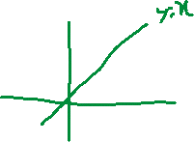

(b) and the *x*-axis.

Area=

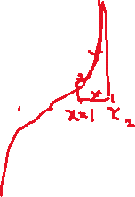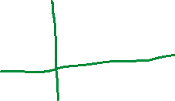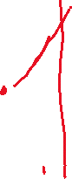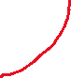

(c) .

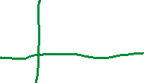

Area=



(d) and the *x*-axis.

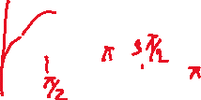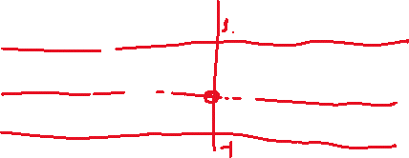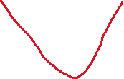

(e) the *x*-axis and the lines and

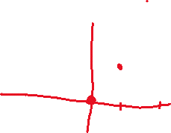

(f) and the *x*-axis.

Point of intersections

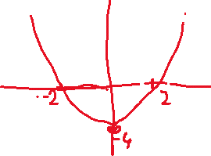

Area=



(g) and the *y*-axis.

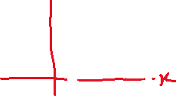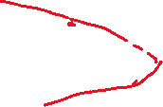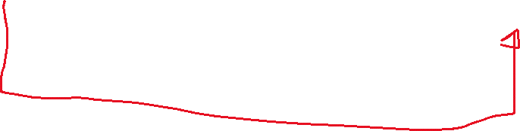

(h) and the *x*-axis.

